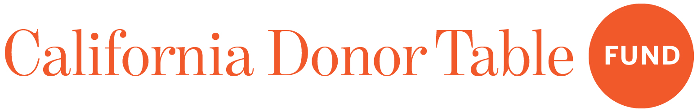

How Funders Can Engage in California’s Recall Elections
By: Rebecca M. Hamburg, Chief Network Officer, California Donor Table Fund
(rebecca@californiadonortablefund.org)

California is facing an unprecedented wave of recalls threatening our democracy. Disinformation and voter suppression could deeply impact these off-year special elections by encouraging low voter turnout. To fight off these threats, the grantees of the California Donor Table Fund and their partner organizations need sustained support from funders who share our belief that leadership by people and communities of color is what it takes to create a California where all people have fair and equal access to health, prosperity, and justice. Funders can and should step up to help ensure that this vision is realized by strong turnout in these off-cycle elections. Here are the top 5 ways foundations can engage their grantees and the communities they support around the recalls:

- Know the Rules: As you likely know, public charities and private foundations are prohibited from supporting or opposing candidates for public office. The IRS has not issued guidance on recall elections; however, because the gubernatorial election, for example, asks voters to choose a replacement in the event the governor is recalled, it is likely that charities and private foundations cannot campaign on either the question of removal or the recall vote that functions to elect a replacement. Foundations and public charities can engage voters around recall elections in a variety of permissible ways, including funding organizations working to engage voters and educate the public, helping to get out the vote in a nonpartisan way, educating the public about what’s at stake in the election, and ensuring that the election is conducted in a fair manner. Make sure that you keep track of the rules and reporting requirements to ensure that you are able to weather any challenges to your participation in these elections.

- Fund Organizations Engaged in Year-Round Voter Engagement and Power Building: To successfully give communities a voice in the issues that affect them, funders need to invest in long-term organizing and powerbuilding infrastructure, including leadership development, communications systems and structures, and organizational sustainability. CDT grantees, like Million Voters Project Action Fund and Courage California Institute statewide and regional entities like Communities for a New California (CNC), Orange County Civic Engagement Table (OCCET), Inland Empowerment, Alliance San Diego, Engage San Diego, and Lift Up Contra Costa, have been at the vanguard of helping communities of color have a voice in the decisions that affect them. Providing general support grants enables them to continue to reach underrepresented communities of color across the state and ensure that they have the opportunity and willingness to participate in elections that affect them. Community foundations giving non-partisan general operating support to those organizations’ c4 entities would be especially important in connection with these off-cycle elections.

- Educate the Public: A recall election means new deadlines for registration and questions about where and how to vote. All registered voters will be mailed ballots automatically, so it’s important that voters update their information with the Secretary of State as soon as possible. Funders can and should fund efforts to educate the public about how to participate in the political process. Foundations can also help to educate all the candidates about public interest issues at stake in the election. Foundations should award general support grants to organizations engaged in these nonpartisan voter education programs.

- Fund Nonpartisan Get-Out-The-Vote and Voter Registration Drives (Where Permitted): Funders should support organizations that engage and register voters. General support grants are the best way to do this, especially for private foundations. Federal tax law imposes added restrictions on private foundation grants (or other expenditures) earmarked for voter registration drives. Public foundations, on the other hand, are permitted to fund and conduct nonpartisan get-out-the-vote and voter registration drives, and should encourage their grantees to engage in these activities, so long as they are nonpartisan.

- Join Your Colleagues to Align Giving Strategies to Support Communities of Color: If the past several years have taught philanthropy anything, it is that we cannot afford to work in silos and must collaborate with our colleagues and listen to the communities that we support and serve. Funders need to work together with frontline organizations to align their strategies. This is work that CDT does at the state level and in key regions across the state, and we invite you to join us.

On September 14, 2021, California voters will be asked to decide if Governor Gavin Newsom should serve out the remainder of his term or be replaced by one of the myriad challengers. There are also several other recall elections that may take place regarding local district attorneys in California before the statewide regular election in 2022. California funders have an important role to play in ensuring that all California voters know what’s at stake, have a voice in these recall elections, and that their voices are heard. This is especially true for communities of color and those that are typically underrepresented in off-cycle elections like these. California’s democracy is under threat as the will of the voters seeks to be overturned. We invite funders to consider supporting these organizations and strategies to preserve and advance our state.

---
Rebecca M. Hamburg is the Chief Network Officer for the California Donor Table Fund, a community of donors who pool and align nonpartisan investments to advance the state’s progressive movement spanning issues and constituencies. For more information, visit californiadonortablefund.org. Rebecca can be reached at rebecca@californiadonortablefund.org

